**Report for Final Lab**

Group Members: Yihao Wang (7410178057), Jiahui Zhao(8320271522), Pooja Pawar(7854000155)

**Part I Montgomery Multiplication Design**

1. **Brief Description of Design**

In this design, we achieved modular multiplication operation by using Montgomery Reduction Algorithm. In this algorithm, we simplify mod N operation (N is a big number) to mod R (R = 129) which can be implemented by shifting) so we use simple multiplication, addition and subtraction to achieve complex division and then simplify logic.

Firstly, we should implement m = (T*N_i)mod R operation by using one multiplier and shifting operation to calculate T mod R (T = x*y), then another multiplier for calculating m = [T(mod R)]*N_i(mod R). Secondly, we transfer m to S = T*R_i(mod N) by using transfer equation t = (T +mN)/R and generate S based the value of t and N. These are achieved by using one multiplier for mN calculation and RCA for calculating T + mN, ignoring the lower 7bit and treating the upper 8bit as quotient because R = 2^7 = 128. Lastly, we generated S by comparing N and t by using subtraction for comparison

1. **Python Script Code**

"""

The python script for final lab (part1) of ee577a

By Yihao Wang

"""

import time

start_time = time.time()

## Coversion between decimal number and binary number

def dec_to_bin (num,width):

the_num = num

bin_str = ''

if (num < 0 or num >= 2 ** width):

print('the parameter must be [0,' + str(2 ** width - 1) + ']!')

else:

for num in range(width):

bin_str = str(the_num % 2) + ' ' + bin_str

the_num = int(the_num / 2)

return bin_str

## judge if two integers are coprime pair

## Returns True or False

def isCoprime(num_a, num_b) :

t = 0

while num_b >0 :

t = num_a % num_b

num_a = num_b

num_b = t

if num_a == 1 :

return True

else :

return False

## Gets values of sk and rk based on Extended Euclidean Algorithm: a * sk + b * tk = 1

## Returns a list: [sk, tk]

def getEucildean(int_a, int_b) :

r0 = int_a; r1 = int_b; s0 = 1; s1 = 0; t0 = 0; t1 = 1; q = int(r0 /r1)

while r1 != 0 :

r_temp = r1; r1 = r0 -q * r1; r0 = r_temp

s_temp = s1; s1 = s0 - q * s1; s0 = s_temp

t_temp = t1; t1 = t0 - q * t1; t0 = t_temp

if r1 != 0 :

q = int(r0 / r1)

return [s0, t0]

## Gnerates random inputs valuse and calculates outputs

## Returns all values by using list: [inputs, outputs]

def getRandom(inputs,outputs) :

import random

num_r = (2 ** 7)

output = [None] * (len(inputs))

# Generates random N and uses it if N is coprime to R

num_n = random.randint(0, 2 ** 7 - 1)

while not(isCoprime(128, num_n)) :

num_n = random.randint(0, 2 ** 7 - 1)

output[inputs.index('N')] = num_n

num_x = random.randint(0, (2 ** 7 - 1))

num_y = random.randint(0, (2 ** 7 - 1))

while not((num_x * num_y >= 0) and (num_x * num_y <= (num_r * num_n - 1))) :

num_x = random.randint(0, (2 ** 7 - 1))

num_y = random.randint(0, (2 ** 7 - 1))

output[inputs.index('X')] = num_x

output[inputs.index('Y')] = num_y

## Get values of R^(-1) and N^(-1) based on results of getEucildean method

list_temp = getEucildean(num_r, num_n)

num_r_m1 = 0

# Generates value of N_inverse based sk and tk given by function getEucildean()

if (list_temp[0] > 0) and (list_temp[1] < 0) :

output[inputs.index('N-1')] = -list_temp[1]

num_r_m1 = list_temp[0]

else:

output[inputs.index('N-1')] = -(list_temp[1] - num_r)

num_r_m1 = list_temp[0] + num_n

for i in range(len(outputs)) :

output.append((num_x * num_y * num_r_m1) % num_n)

return output

## Generates vector file uisng standard vector file format

def vec_generator (inputs = ['X', 'Y', 'N', 'N-1'], inputs_width = [8, 8, 8, 8], outputs = ['S'], outputs_width = [8], number = 30, clk = 10, delay = 2, unit = 'ns', slope = 0.01, vih = 1.8, vil = 0, file_path = '/Users/yihaowang/Desktop', file_name = 'test_for_MM.vec'):

if (len(inputs) != len(inputs_width)) or (len(outputs_width) != len(outputs)) or (number < 0) or (clk <= 0) or (delay < 0) or(slope < 0) :

print('Parameter Error!')

else :

import os

import random

os.chdir(file_path)

with open(file_name.split('.')[0] + '_' + str(clk) + str(unit) + '.' + file_name.split('.')[1], 'w') as the_file, open(file_name.split('.')[0] + '_golden.txt', 'w') as the_golden :

print('radix', end = ' ', file = the_file)

length = 0

for i in inputs_width :

length += i

for i in range(length) :

print('1', end = ' ', file = the_file)

print('\nio', end = ' ', file = the_file)

for i in range(length) :

print('i', end = ' ', file = the_file)

print('\nvname', end = ' ', file = the_file)

for i in range(len(inputs)) :

for j in range(inputs_width[i]) :

print(inputs[i] + '<' + str(inputs_width[i] - j - 1) + '>', end = ' ', file = the_file)

print('\ntunit ' + unit , file = the_file)

print('slope ' + str(slope), file = the_file)

print('vih ' + str(vih), file = the_file)

print('vil ' + str(vil), file = the_file)

time = delay

for i in range(number) :

random_num = getRandom(inputs, outputs)

print('\n' + str(time), end = ' ', file = the_golden)

print('\n' + str(time), end = ' ', file = the_file)

for j in range(len(inputs)) :

print(inputs[j] + '=' + str(random_num[j]), end = ' ', file = the_golden)

print(dec_to_bin(random_num[j], inputs_width[j]), end = ' ', file = the_file)

for j in range(len(outputs)) :

print(outputs[j] + '=' + str(random_num[len(inputs) + j]), end = '', file = the_golden)

time += clk

print('Successfully Gnererated!')

vec_generator(number = 10, clk = 8, delay = 4)

end_time = time.time()

print('Run Time: %.6fs'%(end_time - start_time))

1. **Function Test**

|  |  |  |  |  |  |  |  |  |  |
| --- | --- | --- | --- | --- | --- | --- | --- | --- | --- |
| X(dec) | Y(dec) | N(dec) | N_i(dec) | S(dec) | X(bin) | Y(bin) | N(bin) | N_i(bin) | S(bin) |
| 19 | 6 | 7 | 73 | 1 | 0010011 | 0000110 | 0000111 | 1001001 | 0000001 |
| 44 | 0 | 23 | 89 | 0 | 0101100 | 0000000 | 0010111 | 1011001 | 0000000 |
| 23 | 57 | 51 | 5 | 21 | 0010111 | 0111001 | 0110011 | 0000101 | 0010101 |
| 120 | 65 | 125 | 43 | 100 | 1111000 | 1000001 | 1111101 | 0101011 | 1100100 |
| 89 | 54 | 111 | 113 | 15 | 1011001 | 0110110 | 1101111 | 1110001 | 0001111 |
| 4 | 29 | 1 | 127 | 0 | 0000100 | 0011101 | 0000001 | 1111111 | 0000000 |
| 46 | 32 | 111 | 113 | 67 | 0101110 | 0100000 | 1101111 | 1110001 | 1000011 |
| 3 | 81 | 5 | 51 | 1 | 0000011 | 1010001 | 0000101 | 0110011 | 0000000 |
| 68 | 64 | 91 | 45 | 34 | 1000100 | 1000000 | 1011011 | 0101101 | 0100010 |
| 20 | 112 | 49 | 47 | 42 | 010100 | 1110000 | 0110001 | 0101111 | 0101010 |

Function Test Waveform of Schematic (clk = 8ns):

Function Test Waveform of Layout(clk = 8ns):

1. **Screenshots**

Schematic:



Layout:

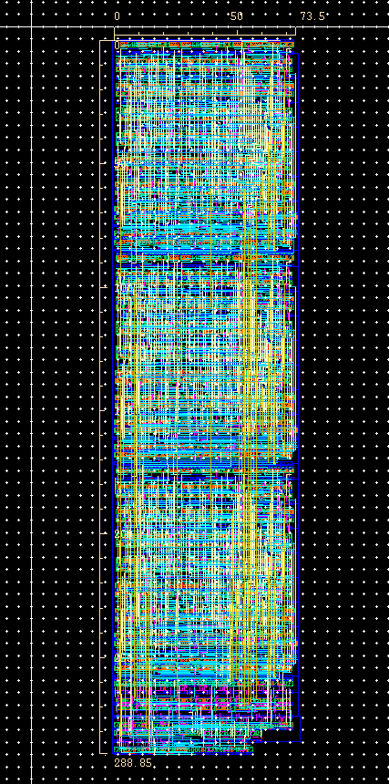

LVS Match:

DRC:

1. **Key Parameters**

Height: 288.85um

Width: 73.5um

Area: 21230um^2

Minimum Clock: 8ns

**Part II RSA Cryptography System**

1. **Brief Description of Design**

**In this design, we implement a decryption unit of cryptography system. It will help restore the plain text m based on cipher text c and private key n, d.The main function is to do calculation of m = Mq + q(q_i(Mp- Mq)mod p). The key part of this calculation is to calculate Mp = (cp^dp)mod p and Mq = (cq^dq)mod q which is called Montgomery Exponential (ME). We implement ME block by using 14 MM (Modular Multiplication Unit) because d is 7bit unsigned number. The upper 7 MM blocks are used to generate (cp*R)mod p, (cp^2 * R)mod p, (cp^4 * R)mod p and (cp^8 * R)mod P and (cp ^ dp)mod p is generated by using MUX and lower 6 MM blocks to generated a combination of former number and using the last MM to eliminate the factor R of output.**

**Using modulo operation unit, we can easily get dp = d mod(p-1), dq = d mod(q-1), cp = c mod p and cq = c mod q and ME will calculate the value of Mp and Mq. To be noted, when we generate (Mp – Mq), if the difference is negative, we will add a q to this difference to make the difference positive. Lastly , we generate the final outputs m by using related 14bit addition, multiplication and Barret Modulo Unit.**

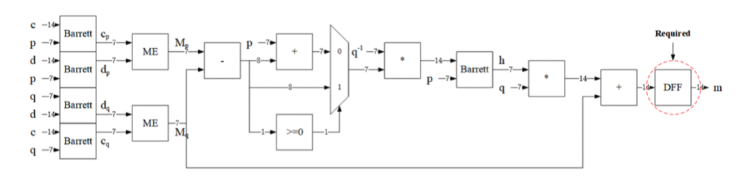

1. **Python Script Code**

"""

The python script for final lab (part2) of ee577a

By Yihao Wang

"""

import time

start_time = time.time()

## Coversion between decimal number and binary number

def dec_to_bin (num,width):

the_num = num

bin_str = ''

if (num < 0 or num >= 2 ** width):

print('the parameter must be [0,' + str(2 ** width - 1) + ']!')

else:

for num in range(width):

bin_str = str(the_num % 2) + ' ' + bin_str

the_num = int(the_num / 2)

return bin_str

## Judges if two integers are coprime pair

## Returns True or False

def isCoprime(num_a, num_b) :

t = 0

while num_b >0 :

t = num_a % num_b

num_a = num_b

num_b = t

if num_a == 1 :

return True

else :

return False

## Gets values of sk and rk based on Extended Euclidean Algorithm: a * sk + b * tk = 1

## Returns a list: [sk, tk]

def getEucildean(int_a, int_b) :

r0 = int_a; r1 = int_b; s0 = 1; s1 = 0; t0 = 0; t1 = 1; q = int(r0 /r1)

while r1 != 0 :

r_temp = r1; r1 = r0 -q * r1; r0 = r_temp

s_temp = s1; s1 = s0 - q * s1; s0 = s_temp

t_temp = t1; t1 = t0 - q * t1; t0 = t_temp

if r1 != 0 :

q = int(r0 / r1)

return [s0, t0]

## Generated the valus of R_inverse and N_inverse based on value of R and N

## Used by MM block

## Returns [R_inverse, N_inverse]

def getRInverse_NInverse_for_MM (r, n) :

temp = getEucildean(r, n)

if ((temp[0] > 0) and (temp[1] < 0)) :

return [temp[0], -temp[1]]

else :

return [temp[0] + n, r - temp[1]]

## Generates P_inverse and Q_inverse for Barret Unit

## Returns [P_inverse, Q_inverse]

def getP_inv_Q_inv(p,q) :

temp = getEucildean(p,q)

num_pi = 0; num_qi = 0

if temp[0] >= 0 :

num_pi = temp[0]

else :

num_pi = temp[0] + q

if temp[1] >= 0 :

num_qi = temp[1]

else :

num_qi = temp[1] + p

return [num_pi, num_qi]

## Return the random number of inputs and the results of outputs (kept in order)

def getRandom(inputs,outputs) :

import random

out = [None] * (len(inputs) + len(outputs))

num_r = 2 ** 7

############ THE ORIGINAL INPUTS ################

num_c = 6757 ##dummy value

num_d = 6593 ##dummy value

num_p = 103 ##dummy value

num_q = 89 ##dummy value

##################################################

############Generation of other inputs based on the inputs c, d, p, q which are given by user###########################################

num_pm1 = num_p - 1

num_qm1 = num_q - 1

num_pr = int((2**14) / num_p)

num_qr = int((2**14) / num_q)

num_pm1r = int((2**14) / num_pm1)

num_qm1r = int((2**14) / num_qm1)

num_pmm = getRInverse_NInverse_for_MM(num_r, num_p)[1]

num_qmm = getRInverse_NInverse_for_MM(num_r, num_q)[1]

(num_pi, num_qi) = getP_inv_Q_inv(num_p, num_q)

num_rp = (num_r ** 2) % num_p

num_rq = (num_r ** 2) % num_q

num_cp = num_c % num_p

num_cq = num_c % num_q

num_dp = num_d % (num_pm1)

num_dq = num_d % (num_qm1)

num_mp = (num_cp ** num_dp) % num_p

num_mq = (num_cq ** num_dq) % num_q

if (num_mp - num_mq) >=0 :

num_h = (num_qi * (num_mp - num_mq)) % num_p

else :

num_h = (num_qi * (num_mp - num_mq + num_p)) % num_p

num_m = num_q * num_h + num_mq

num_n = num_p * num_q

num_check = num_p * num_pi + num_qi * num_q

if num_check % num_n == 1 :

print('Bazout identity satisfied!!')

else :

print('Bazout identity failed to check!')

##########################################################################################################################################

out[inputs.index('P')] = num_p

out[inputs.index('Q')] = num_q

out[inputs.index('P-1')] = num_pm1

out[inputs.index('Q-1')] = num_qm1

out[inputs.index('P_R')] = num_pr

out[inputs.index('Q_R')] = num_qr

out[inputs.index('P-1_R')] = num_pm1r

out[inputs.index('Q-1_R')] = num_qm1r

out[inputs.index('C')] = num_c

out[inputs.index('D')] = num_d

out[inputs.index('Q_I')] = num_qi

out[inputs.index('P_MM')] = num_pmm

out[inputs.index('Q_MM')] = num_qmm

out[inputs.index('Rp')] = num_rp

out[inputs.index('Rq')] = num_rq

out[outputs.index('M') + len(inputs)] = num_m

return out

## Generates vector file uisng standard vector file format

def vec_generator (inputs = ['P','Q','P-1','Q-1','P_R','Q_R','P-1_R','Q-1_R','C','D','Q_I','P_MM','Q_MM','Rp','Rq'], inputs_width =[7,7,7,7,14,14,14,14,14,14,7,7,7,7,7], outputs = ['M'], outputs_width = [7], number = 30, clk = 20, delay = 2, unit = 'ns', slope = 0.01, vih = 1.8, vil = 0, file_path = '/Users/yihaowang/Desktop', file_name = 'super_test_final_3.vec'):

if (len(inputs) != len(inputs_width)) or (len(outputs_width) != len(outputs)) or (number < 0) or (clk <= 0) or (delay < 0) or(slope < 0) :

print('Parameter Error!')

else :

import os

import random

os.chdir(file_path)

with open(file_name, 'w') as the_file, open(file_name.split('.')[0] + '_golden.txt', 'w') as the_golden :

print('radix', end = ' ', file = the_file)

length = 0

for i in inputs_width :

length += i

for i in range(length) :

print('1', end = ' ', file = the_file)

print('\nio', end = ' ', file = the_file)

for i in range(length) :

print('i', end = ' ', file = the_file)

print('\nvname', end = ' ', file = the_file)

for i in range(len(inputs)) :

for j in range(inputs_width[i]) :

print(inputs[i] + '<' + str(inputs_width[i] - j - 1) + '>', end = ' ', file = the_file)

print('\ntunit ' + unit , file = the_file)

print('slope ' + str(slope), file = the_file)

print('vih ' + str(vih), file = the_file)

print('vil ' + str(vil), file = the_file)

time = delay

for i in range(number) :

random_num = getRandom(inputs, outputs)

print('\n' + str(time), end = ' ', file = the_golden)

print('\n' + str(time), end = ' ', file = the_file)

for j in range(len(inputs)) :

print(inputs[j] + '=' + str(random_num[j]), end = ' ', file = the_golden)

print(dec_to_bin(random_num[j], inputs_width[j]), end = ' ', file = the_file)

for j in range(len(outputs)) :

print(outputs[j] + '=' + str(random_num[len(inputs) + j]), end = '', file = the_golden)

time += clk

print('Successfully Gnererated!')

vec_generator(number = 1, clk = 20, delay = 5)

## For testing the program

#print(getRInverse_NInverse_for_MM(128,113))

#getRandom([],[])

end_time = time.time()

print('Run Time: %.6fs'%(end_time - start_time))

1. **Function Test**

|  |  |  |  |  |  |  |  |  |
| --- | --- | --- | --- | --- | --- | --- | --- | --- |
| Inputs | | | | | | | | Outputs |
| Given | | | | Python | | | | Hardware |
| c | d | p | q | rp | p_i | rq | q_i | m |
| 4624 | 9833 | 107 | 97 | 13 | 68 | 88 | 32 | 4321 |
| 6757 | 6593 | 103 | 89 | 7 | 70 | 8 | 22 | 2468 |
| 831 | 2971 | 127 | 113 | 1 | 105 | 112 | 9 | 1314 |
| 4058 | 2831 | 113 | 109 | 112 | 82 | 34 | 28 | 5566 |
| Metric | | | | | | | | |
| Time (ns) | | | Area (mm^2) | | | Area * Time | | |
| 130.65 | | | 0.851 | | | 111.24 | | |

Waveform of Schematic (clk = 13ns):

Waveform of Layout (clk = 13ns):

1. **Screenshots**

Schematic of Montgomery Exponential Unit:

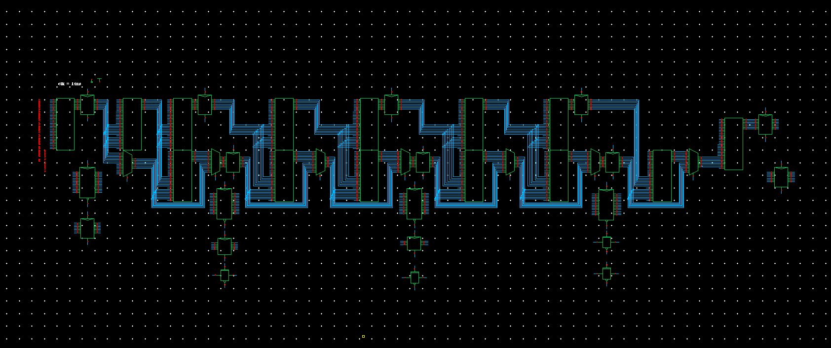

Schematic of Complete Circuits:

Layout:

LVS Match:

DRC:

1. **Key Parameters**

Height: 1176.3um

Width: 724.05um

Area: 851700 um^2

Minimum Clock: 13ns